College of Arts and Sciences
Division of Natural and Mathematical Sciences

Department of Microbiology

484 West 12th Avenue
Columbus, OH 43210

614-292-2301 Phone
614-292-9120 Fax

January 4, 2017
To: Chair of ASCC
From: Charles J. Daniels, Chair ASCC Natural and Mathematical Sciences Panel

Dear colleagues,

At our meeting on Wednesday, November 30th, the Natural and Mathematical Sciences Panel reviewed the proposal from the College of Optometry for the Bachelor of Science in Vision Science (B.S. V.S.). This is a late submission for semester conversion of a preexisting program under the quarter system.

The submission is a direct conversion of the quarter system program. Students enrolled in the program will complete their general requirements for the B.S. degree during their first three years. Following this, students will enter the College of Optometry and complete the curriculum for the first year of the Doctor of Optometry (O.D.) program in their fourth year of the B.S. V.S. degree program.

The B.S. V.S. program will provide OSU a completive advantage in recruiting the best applicants as well as lessening the financial burden for these students by shortening the O.D. program from seven to six years.

Following minor revisions, the committee unanimously approved the proposal.

Respectfully,
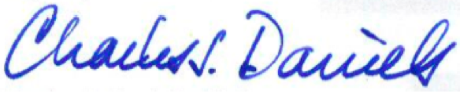

Charles J. Daniels, Ph.D.

